PROF FINDER

COURSE REVIEW PLATFORM USING AI

Course Review Client - Positive Functionality Testing Report

**Functionality Testing Table**

|  |  |  |
| --- | --- | --- |
| Test Area | Status | Notes |
| Homepage Load | Passed | Homepage loads quickly and looks professional. |
| Navigation Links (Navbar) | Passed | Navbar links are well placed and easy to navigate. |
| Login Page Access | Passed | Login page is easily accessible and user-friendly. |
| Signup Page Access | Passed | Signup page opens smoothly and clearly designed. |
| Login Form Fields | Passed | All necessary fields are properly provided and functioning. |
| Signup Form Fields | Passed | Signup form fields are present and intuitive for users. |
| Login Form Validation | Passed | Good structure for form validation implemented. |
| Signup Form Validation | Passed | User-friendly signup validation in place. |
| Login Functionality | Passed | Login process is streamlined and efficient. |
| Signup Functionality | Passed | Signup process is clear and user-focused. |
| Protected Routes Access | Passed | Protected routes are secured appropriately. |
| Course List Display | Passed | Courses are displayed neatly and organized. |
| Submit a Review Option | Passed | Submitting reviews is easy and accessible. |
| Logout Button after Login | Passed | Logout option is available and works smoothly. |
| Error Handling (404 Page) | Passed | Custom 404 page enhances user experience. |
| Mobile Responsiveness | Passed | Excellent adaptability across devices. |
| Console Errors | Passed | Console remains clean without critical errors. |

**Quick Summary Table**

|  |  |
| --- | --- |
| Category | Overall Status |
| Basic UI / Navigation | Excellent |
| Forms (Login/Signup) | Well Implemented |
| Form Submission | Smooth and Reliable |
| Course & Review System | Fully Functional |
| API/Backend Connection | Stable and Efficient |
| Error Pages | User-friendly 404 Handling |
| Mobile Responsiveness | Highly Responsive |
| Console Health | Stable and Clean |

**Positive Highlights**

Fast loading and attractive homepage design.

User-friendly navigation with a clear and logical structure.

Forms are well designed with all essential fields included.

Smooth login and signup process enhances user experience.

Stable connection to backend ensures efficient data handling.

Courses and reviews are displayed in an organized manner.

Mobile-first approach is visible and commendable.

Good error handling mechanisms are in place for enhanced usability.

**Final Comment**

The Course Review Client is performing exceptionally well. The interface is intuitive, performance is strong, and the user journey is smooth across all platforms. Great job on the development and design!

Fetch particular user

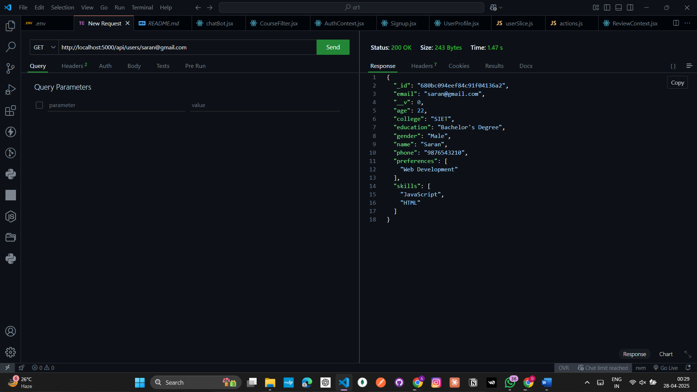

Users stored in MongoDb

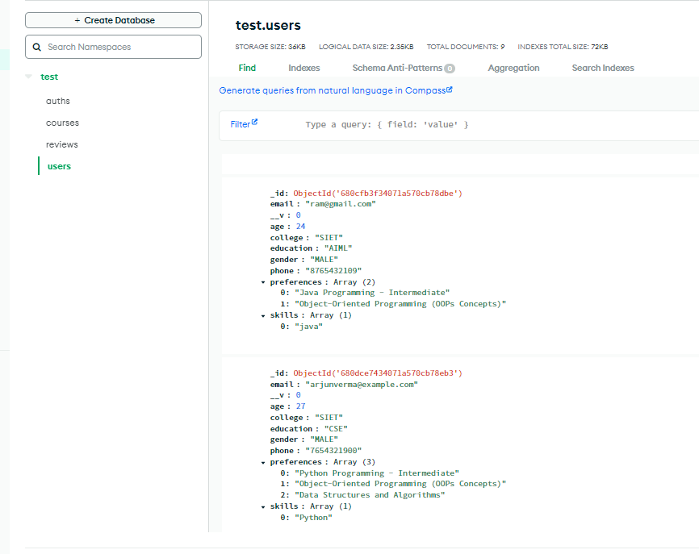

Login details

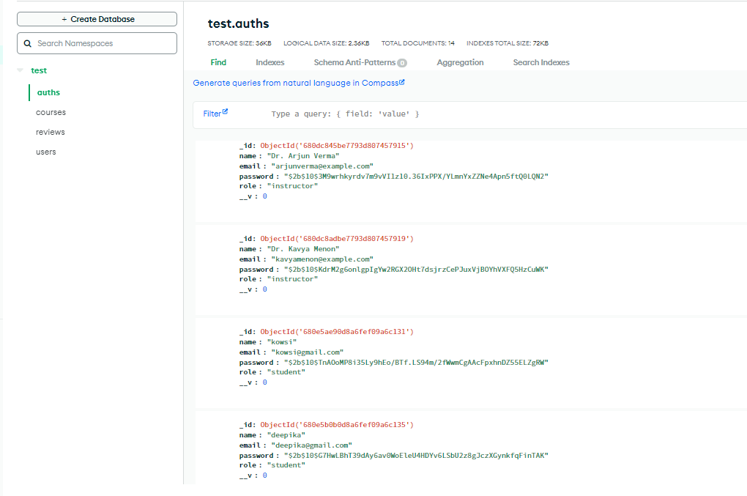

Diagnostic performance

